A000-Asia-Gandhara-Buddha- Holding the Jewel Mudra

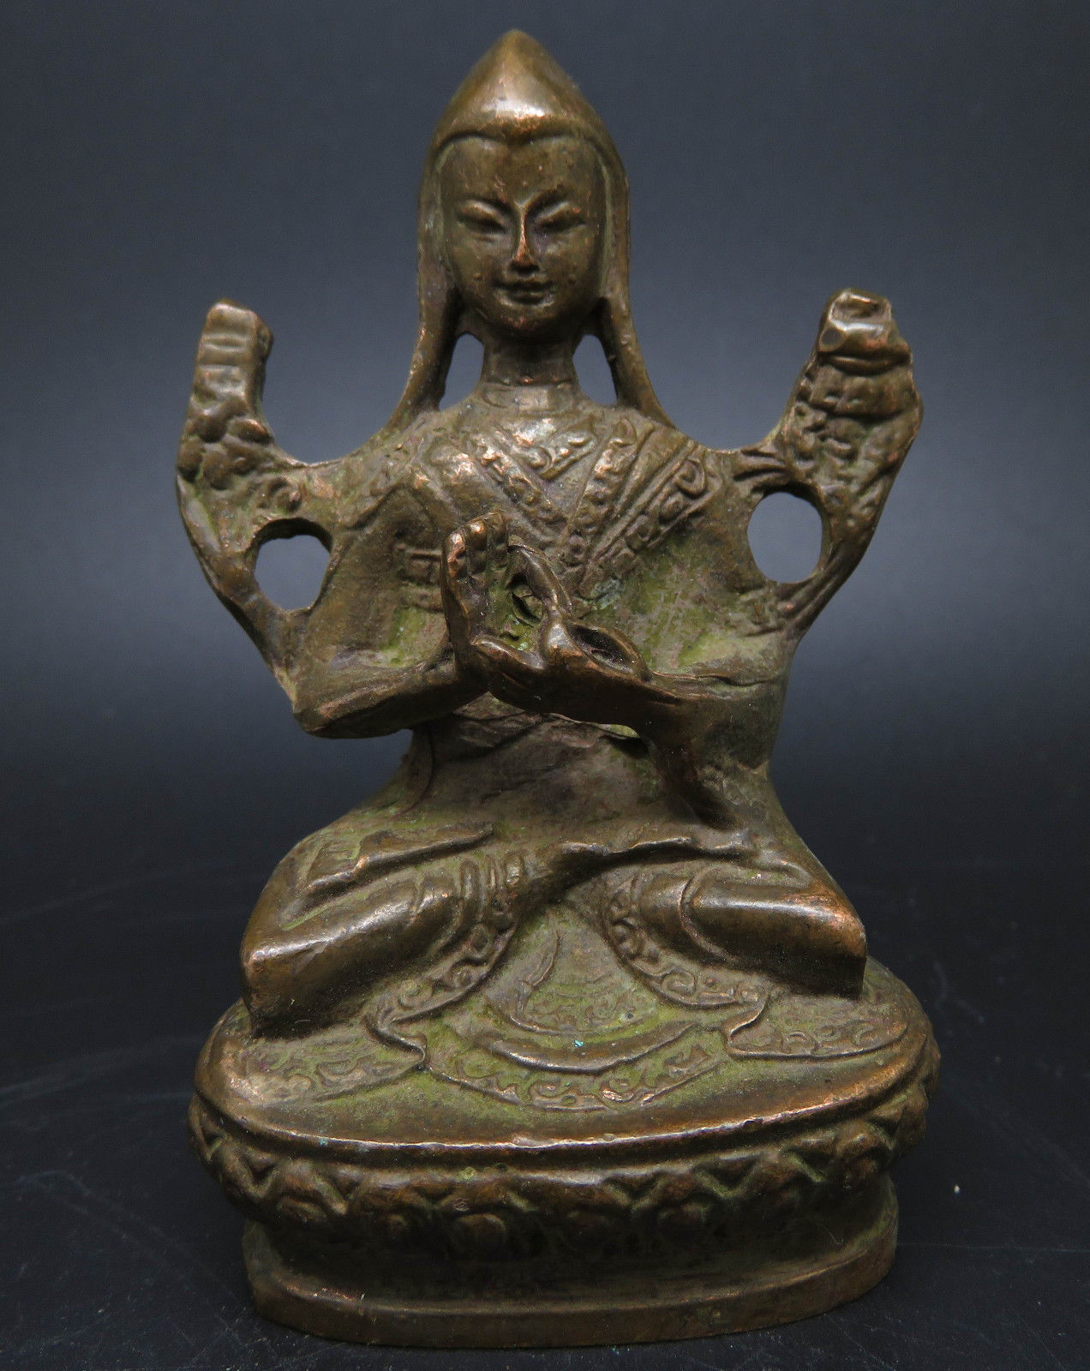 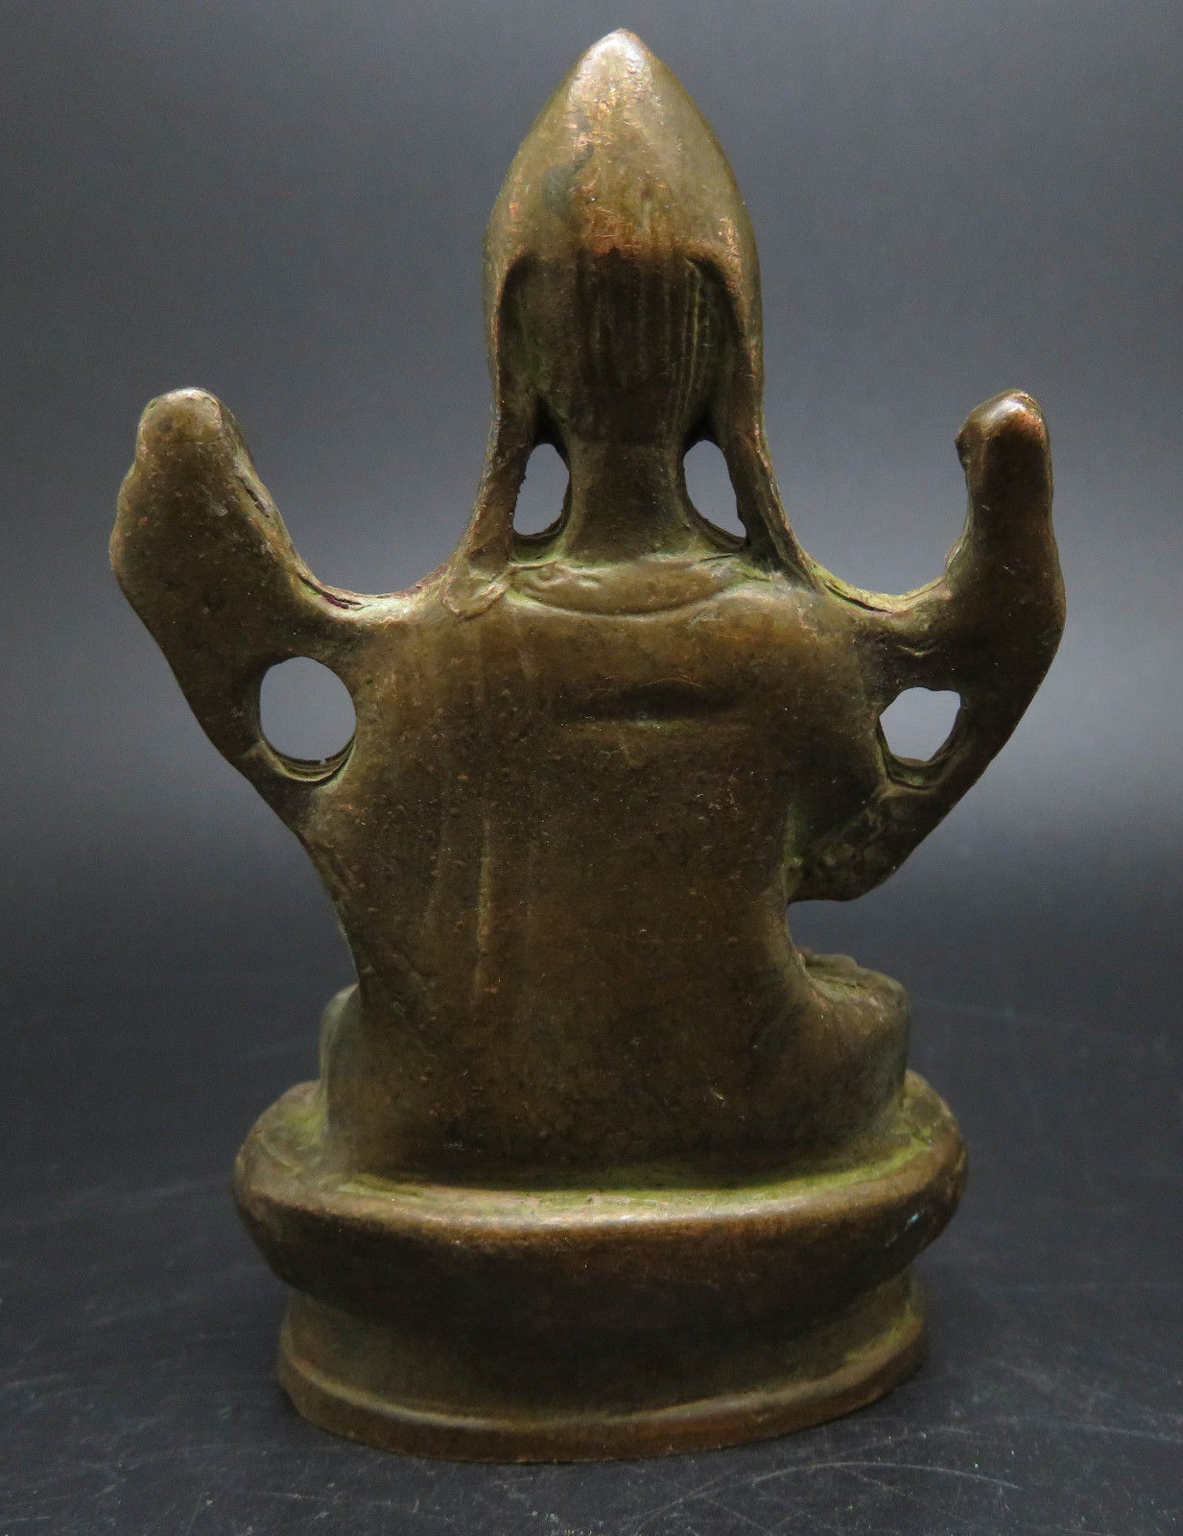

|  |  |  |
| --- | --- | --- |
| **"Gesture of Holding the Jewel"**  (manidhara) The hands are arched and hold a wishing jewel, which can not be seen because of its transparency. This is a mudra of Avalokiteshvara, and is often confused with the similar gesture of greeting. | |  | | --- | | http://www.buddhas-online.com/mudras2/M19.gif | |